FOR IMMEDIATE RELEASE
Contact: Don Kennedy, Marketing Specialist, TecNiq, Inc.

TecNiq Inc. Announces New Stop/Tail/Turn/Reverse Light
TecNiq Introduces New 4” Round Stop, Tail, Turn, Reverse Light – Perfect Replacement for Existing 4” Standard Sizes.

Galesburg, MI – December 2, 2021 – TecNiq Inc. announces their new T42 Stop, Tail, Turn, Reverse light. The T42 is a 4” round, grommet mount replacement, for any standard sized 4” round light. The T42 features (12) Red LEDs, and (4) White LEDs, which meet all FMVSS 108 requirements for wide and narrow vehicles. Available with Amp connector, or Tri-Pole connector – the T42 is designed to be a great looking light that provides Work Trucks, Heavy Duty Trailers, Light Duty Trailers, and more with a high quality, no hassle lamp. The T42 runs on a voltage range from 9-14V DC and allows customers to save time and money with a combination of functions built into one light. The T42 is IP68 rated and hermetically sealed to be dust and waterproof.
The T42 joins TecNiq’s industry leading DOT lighting catalog and gives manufacturers of commercial vehicles another option for their existing customers. In addition, it offers a 100% sealed light for any new customers utilizing these sized lights from TecNiq’s competitors.
“The creation of the T42 is a great example of TecNiq’s ability to deliver what our customers need. With current market conditions, more customers are leaning on TecNiq to help with sourcing challenges. The T42 was specifically created to help a customer continue to deliver vehicles. We constantly encourage our customers to bring forth new ideas and opportunities that we may be able to help with.
Kevin Shaffer, National Sales Manager – TecNiq Inc.

TecNiq’s T42 is available to order now, for samples and specs reach out to their sales team at www.TecNiqInc.com, or 269-629-4440.
Features:
- Save time and money with our new combination Stop/Tail/Turn and Reverse Light
- Fits all standard 4” round applications
- IP68 Rated - Dust and waterproof with hermetic seal
- Meets all FMVSS 108 requirements for wide and narrow vehicles
- Reliable performance over 100,000 hours
- Lifetime Warranty
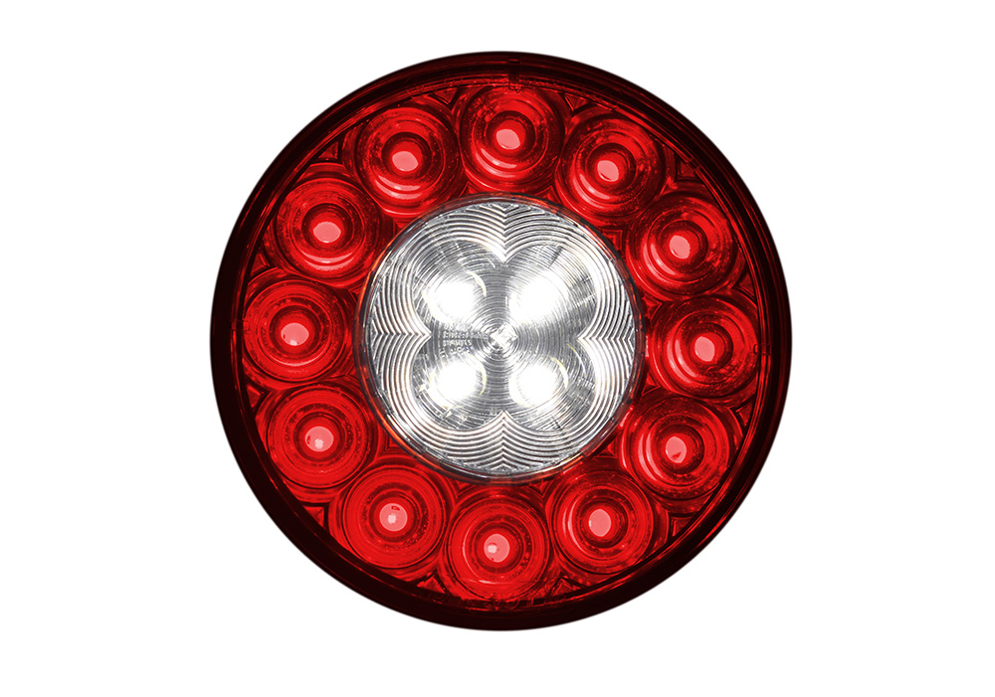

TecNiq Inc. is an engineer owned & operated company with a strong commitment to excellence. We begin with a simple belief in offering the greatest value, the highest quality lighting solutions, and great customer care. We use the highest quality LEDs, materials, and offer market leading technologically advanced lighting solutions. From fleet vehicles, construction trailers, boats, emergency response vehicles, heavy or light duty equipment, you can expect your lights to work every time. Our goal is to exceed your product quality expectations. We feel so strongly about our commitment to quality, that we back every one of our products with a no-nonsense Lifetime Warranty.

